Computing AQI

The air quality index is a piecewise linear function of the pollutant concentration. At the boundary between AQI categories, there is a discontinuous jump of one AQI unit. To convert from concentration to AQI this equation is used:

$$I=\frac{I_{high}-I_{low}}{C_{high}-C_{low}}\left(C-C_{low}\right)+I_{low}$$

Where:

I = the (Air Quality) index,

C = the pollutant concentration,

Clow = the concentration breakpoint that is ≤ C,

Chigh = the concentration breakpoint that is ≥ C,

Ilow = the index breakpoint corresponding to Clow,

Ihigh= the index breakpoint corresponding to Chigh.

EPA's table of breakpoints is:

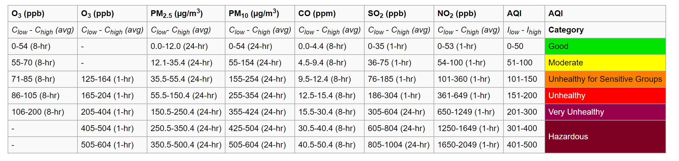

If multiple pollutants are measured at a monitoring site, then the largest or "dominant" AQI value is reported for the location.